Guide of project :

1. Create asp.net core api project for backend
2. Add configurations for db , after create schema and alpha db

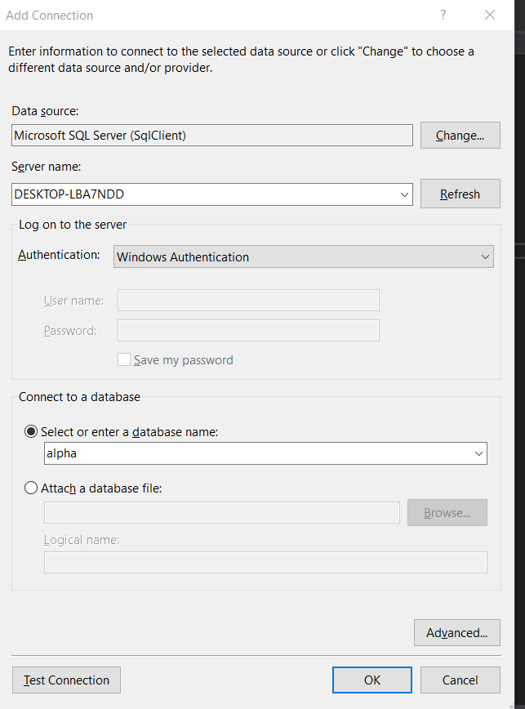

1. Test db connection
2. Design database
   1. Start Countries table :

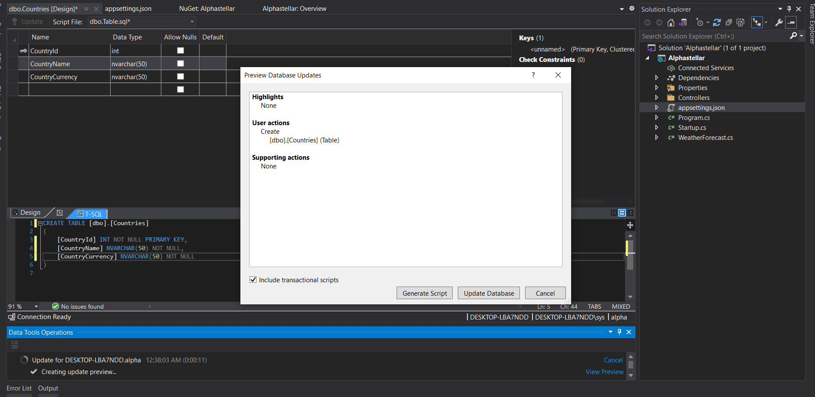

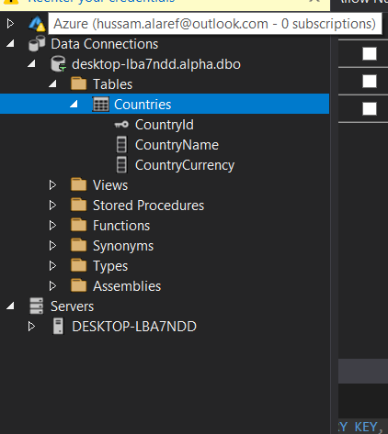

* 1. Then add holidays table with define countryId forging key

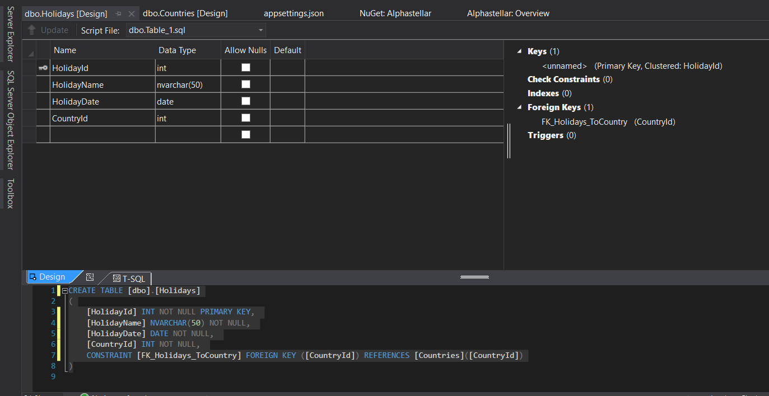

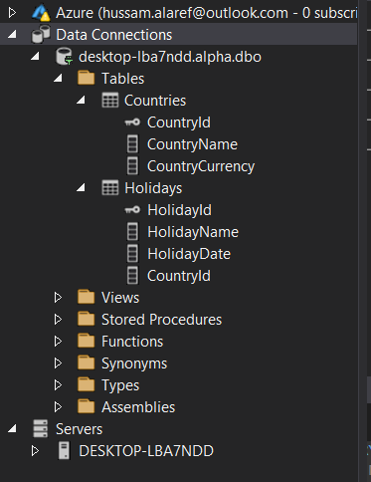

* 1. Book table

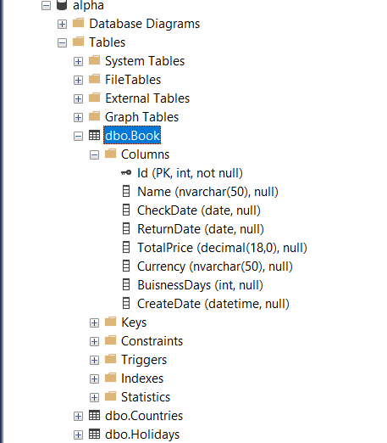

* 1. Seed data into countries table

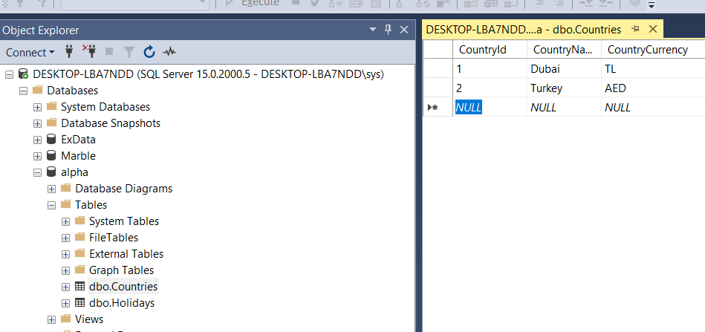

* 1. Seed data into holidays table

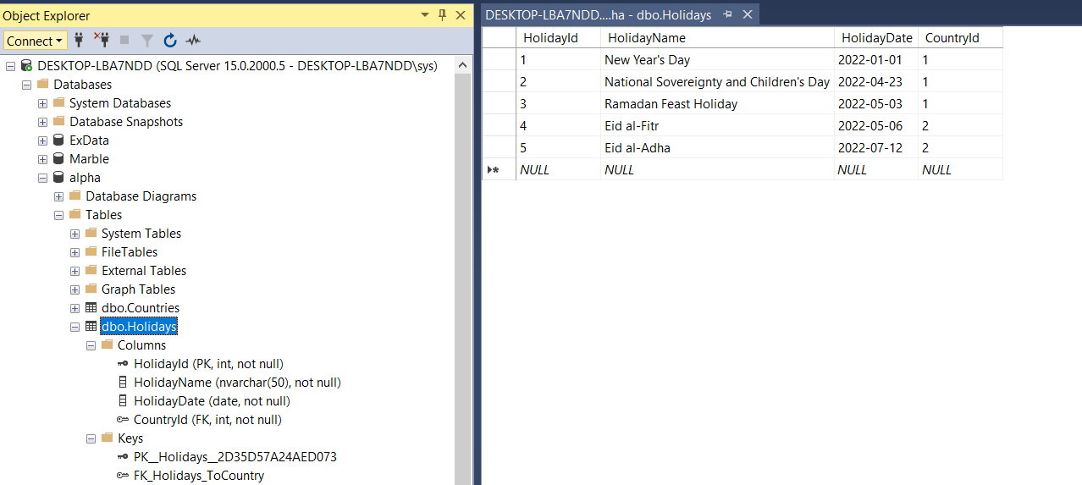

1. Start create layers of code

* Models
  + Add holiday model
  + Add country model
* DataAccess(Context)
  + Create dbContext class (EntityFrameworkCore nuGet)
  + DBset for all models we use it .
* DataProcess
  + Calculate Buisness days
  + Calculate Penalty
* Interfaces
  + Create interface give us ability to substitute a simulated data source for a repository
* Controllers : Get,Post our API

**Screenshots** - Backend project – API’S

----------------------------------------------------

